HOW TO WIN MORE BIDS

Using Your SSIP Accreditation

Once accredited, this is how to use your SSIP status to stand out
from competitors and win more contracts
A free guide from Sam Kerr — Train in Health & Safety

For UK contractors, subcontractors, and SMEs.
Train in Health & Safety Ltd
Helping UK businesses achieve and maintain SSIP accreditation with less stress, less paperwork, and complete confidence.
traininhealthandsafety.com | 📞 +44 2080 593633 | info@traininhealthandsafety.com

This guide answers:
• How SSIP on your website, van, and letters wins clients before you bid
• The internal marketplace route — how buyers find and contact you directly
• The external route — exactly how to find and win public sector tenders
• Where the contracts are actually hiding
• The 8 mistakes that get accredited contractors disqualified

Disclaimer: The strategies in this guide are based on tried-and-tested approaches used by UK contractors. Results vary. Nothing here guarantees specific outcomes. Train in Health & Safety Ltd accepts no liability for actions taken based on this guide.

Introduction

Your SSIP Badge Is a Marketing Tool — Use It Like One
Most contractors treat SSIP accreditation as a compliance exercise. The smart ones treat it as a competitive advantage.
Before a client allows you onto site or adds you to their approved list, they need confidence that you're competent and manage health and safety properly. Your SSIP badge provides that reassurance through independent assessment, before you've said a single word.
Where to display your accreditation
Every one of these touchpoints is a trust signal to a potential client:
- Your website — homepage and 'About Us' page (buyers Google you before they call)
- Van livery — visible proof of compliance on every job you attend
- Email signature — every message you send carries your accreditation
- Quotations and estimates — it tells clients you're serious before they read the price
- Letterhead and proposal documents
- LinkedIn company profile and any business social media
- Tender submissions and PQQ documents
For buyers comparing several similar contractors, visible accreditation on your website and vehicles can influence who gets invited to quote, who gets shortlisted, and who gets added to an approved supplier list. It's a passive sales tool that works around the clock.

Not sure which scheme is right for your market?
Book a free consultation and Sam will tell you exactly which to go for, and save you money on schemes your buyers don't actually use. traininhealthandsafety.com | +44 2080 593633

traininhealthandsafety.com | info@traininhealthandsafety.com | +44 2080 593633

Where the Contracts Are Actually Hiding

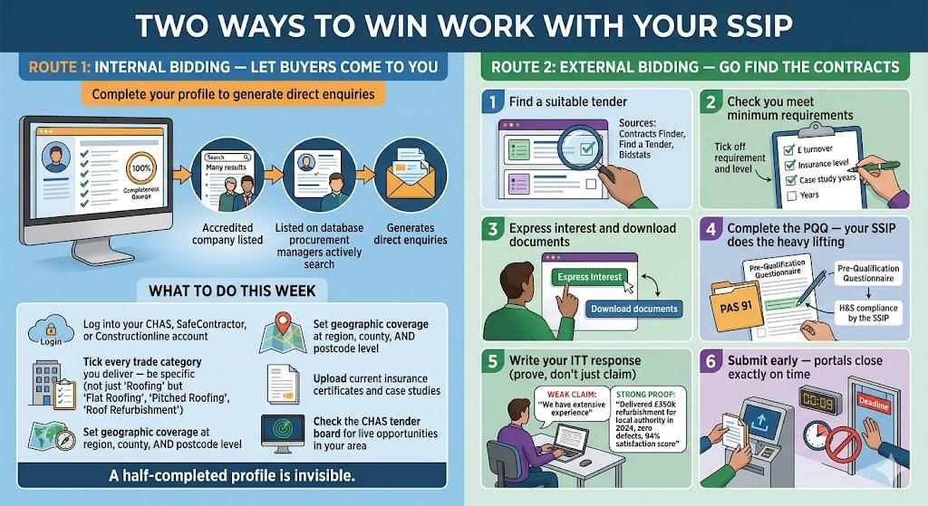

The UK public sector spends over £300 billion every year through competitive procurement. Most opportunities are publicly listed, free to access, free to bid on. The contractors winning them just know where to look.
Route 1: Internal marketplace (let buyers come to you)
When you're accredited, your company is listed on a database directory that procurement managers actively search. Buyers use these portals to search for accredited contractors and if your profile is complete, they find you.

- CHAS Client Portal: Over 32,500 pre-qualified contractors listed. Buyers search by trade, location, and compliance level. Log in, tick every trade category you deliver, and keep your profile complete.

- Constructionline Marketplace: Over 500,000 project leads on the Marketplace platform, accessible to 10,000 buyers from 3,800 organisations. At Gold level, buyers can find you in their searches and send Invitation to Tender (ITT) enquiries directly. Constructionline also runs Marketplace Live events in cities across the UK where Tier 1 contractors and public sector buyers attend to find accredited subcontractors. These are free to attend as a member and the direct relationships you build there are worth more than most tender submissions.

Real example: Mace insists their subcontractors hold CHAS. When they need an electrical contractor, they search the CHAS database filtered by trade, location, and compliance level. A complete profile means your name appears. They contact you directly.

Route 2: External Tender Portals (free to use)

Portal | Website | What it covers
Find a Tender | find-tender.service.gov.uk | The UK's official platform for all above-threshold public sector contracts. Since February 2025, this is where high-value public sector body like central government, NHS, councils, housing associations, police, and more publish. Set keyword alerts for your trade and region.
Contracts Finder | contractsfinder.service.gov.uk | Covers lower-value contracts in England from £10,000 upward, which makes it accessible for SMEs.  Also shows contract award notices showing who holds current contracts and when they expire. Use it as market intelligence as much as a live bid.
Bidstats | bidstats.uk | Free tender search engine pulling opportunities from multiple sources.  Pulls from Contracts Finder, Find a Tender, and OJEU in one place. Good for a quick daily scan. No login required.
Public Contracts Scotland | publiccontractsscotland.gov.uk | All Scottish public sector work.
Sell2Wales | sell2wales.gov | Welsh public sector procurement.
eSourcingNI / eTendersNI | esourcingni.co.uk | etendersni.gov.uk | Northern Ireland public sector.

Route 3: Housing Associations
About 1,600 housing associations procure responsive maintenance, planned works, and construction independently, mostly outside the main public portals. Many use Dynamic Purchasing Systems (DPS) frameworks that stay permanently open for new suppliers to join.

- Procurement for Housing (PfH) — procurementforhousing.co.uk (covers 1,100+ housing associations)
- LHC Procurement Group — lhcprocure.org.uk (social housing and public property frameworks)
- Fusion21 — fusion21.co.uk
- Pagabo — pagabo.co.uk
- Housing Procurement Portal — housingprocurement.com

Route 4: Getting Into Tier 1 Supply Chains
Major contractors manage supply chains of specialist subcontractors. SSIP accreditation at the right level is a core requirement to get on their approved lists. Register directly:

Contractor | What They Require | Where to Register
Balfour Beatty | Constructionline Gold or CAS minimum required for all supply chain partners. Register via Constructionline. | constructionline.co.uk
Kier | Constructionline Gold/CAS required from Jan 2022. Register via Constructionline using code KIER25. | constructionline.co.uk/buyers/partnership/kier-partnership-page
Morgan Sindall | Supply chain registration form on their website. SSIP/CAS required. | morgansindallconstruction.com/supply-chain
Skanska UK | Dedicated supplier portal for supply chain partners. | skanska.co.uk/supply-chain
Wates / VINCI / BAM | Constructionline Gold specified as minimum standard. | constructionline.co.uk

The 6-Step Process to Win a Tender
Most contractors who are accredited but not winning tenders are making process errors, not product errors. Here's the method that works.

1 | Find a tender requiring SSIP  Search on Contracts Finder, Find a Tender, or Bidstats. Specifically look for tenders that require SSIP, these attract fewer bidders because most contractors aren't accredited. That's your competitive advantage right there.

2 | Check you meet the minimum requirements  Before investing time: Is your turnover at least 2x the annual contract value? Is your insurance at the required level (£5m public liability minimum; £10m for NHS)? Is your SSIP current and matching what's specified? Do you have comparable case studies from the last 3-5 years? No to any of these, I’d say don't bid.

3 | Read the evaluation criteria first  Not the specification, but the evaluation criteria. These tell you exactly what you'll be scored against. Look for scoring matrices (5/5 vs 3/5 descriptors). Use the buyer's own language in your answers. Check previous award notices on Contracts Finder to understand the competitive price range.

4 | Complete the PQQ using your SSIP documents  Your SSIP certificate directly satisfies the H&S pre-qualification sections. Build a PAS 91 pack — policies, RAMS, case studies, insurance, SSIP docs — once. Reuse it across all applications. Constructionline Gold members are exempt from certain PAS 91 sections.

5 | Write ITT responses that prove capability  Weak: 'We have extensive experience in similar projects.'Strong: 'We delivered a £350,000 school refurbishment for a local authority in 2025, completed on programme, with zero defects and a 94% satisfaction score.'Every claim needs a specific, quantified, verifiable proof point.

6 | Submit early and always request a debrief  Portals close exactly at the stated deadline, so upload at least 2 hours early. Then request a formal debrief on every result, win or lose. Under the Procurement Act 2023, you're entitled to one. The contractors who improve fastest are the ones who always ask.

8 Mistakes That Get Accredited Contractors Disqualified

These are the exact reasons bids get rejected and contracts go to competitors.

1. Letting SSIP lapse before the tender deadline
A lapsed certificate = instant disqualification, regardless of bid quality. Set a renewal reminder 8 weeks before expiry. Check your live status on ssipportal.org.uk before every submission.

2. An incomplete accreditation profile
Missing trade categories, outdated insurance docs, no case studies. Buyers search — and if your profile is half-filled, they don't find you. A half-completed profile is invisible.

3. Not using Deem to Satisfy
Paying for a full H&S reassessment when your existing SSIP certificate already satisfies the requirement. Don't pay twice. Use the Deem to Satisfy transfer. It exists specifically to save you this cost.

4. Only targeting large contracts
Low-value tenders (under £100k) have less competition, faster turnaround, and build the case study track record that qualifies you for bigger work. Start here. Build the evidence base. Then go bigger.

5. Generic bids with no evidence
'We have extensive experience' earns almost no marks. Specific, quantified, verifiable proof points score high. Every claim needs evidence — a client type, a contract value, a completion rate, a satisfaction score.

6. Ignoring social value
Social value is worth 10-30% of the total score on most public sector tenders. Make concrete, measurable commitments — specific numbers, timescales, and delivery evidence. Vague statements score almost nothing.

7. Bidding for contracts where your turnover doesn't qualify
Most buyers require your annual turnover to be at least double the annual contract value. Apply this filter yourself before investing time in a bid you'll be disqualified from.

8. Never asking for a debrief after losing
You're entitled to a formal debrief on any lost bid under the Procurement Act 2023. The debrief gives you your actual score and exactly where you fell short. The contractors who improve fastest are the ones who always ask.

NEED HELP GETTING YOUR ACCREDITATIONS IN ORDER BEFORE YOU START BIDDING?
Let Sam take it off your plate.
Many contractors understand the value of SSIP accreditation but simply do not have the time to deal with the paperwork, documentation reviews, policy updates and application requirements involved.

Getting your SSIP accreditation done yourself is time-consuming, confusing, and one wrong document can mean a failed application. Sam takes the hassle and headache out of the whole process by handling your documentation, identifying every gap, and submitting your application on your behalf.
Sam also builds full bid documentation libraries: H&S policies, risk assessments, method statement templates, and pre-qualification evidence packs — so you're ready to bid the moment your accreditation lands.

Book a FREE 20-minute consultation with Sam
www.traininhealthandsafety.com
info@traininhealthandsafety.com
+44 2080 593633

SSIP & CHAS Done-For-You · Bid Documentation Libraries · NEBOSH & IOSH Training · H&S Compliance Support

DISCLAIMER
The strategies and resources in this guide are based on tried-and-tested approaches used by UK contractors to win tenders. Tender outcomes depend on many factors including competition, pricing, and client requirements. Nothing in this guide constitutes a guarantee of results. Train in Health & Safety Ltd accepts no liability for outcomes resulting from actions taken based on this guide.
© Train in Health & Safety | traininhealthandsafety.com | For personal and business use only. All rights reserved.

